# Mechanical assembly of COSI Measure v.1.0

Please find below the documentation to mechanically assemble COSI Measure v.1.0. If you find any flaws or if you have any suggestions with regards to this document or project please let us know [info@opensourceimaging.org](mailto:info@opensourceimaging.org). We are only human!

Documentation published describing Hardware is licensed under the CERN OHL v. 1.2. You may redistribute and modify this documentation under the terms of the CERN OHL v.1.2. (<http://ohwr.org/cernohl>) except otherwise stated.

This documentation is distributed WITHOUT ANY EXPRESS OR IMPLIED WARRANTY, INCLUDING OF MERCHANTABILITY, SATISFACTORY QUALITY AND FITNESS FOR A PARTICULAR PURPOSE. Please see the CERN OHL v.1.2 for applicable conditions.

# Step 1

Assemble the aluminium frame according to the SketchUp design.

# Step 2

Attach ball-screws (all screws should be included in the kit) to fixed and floating bearing.

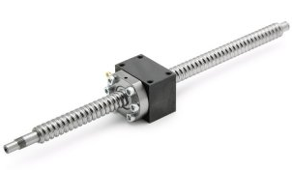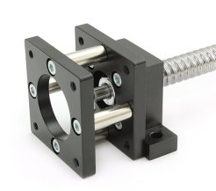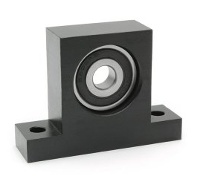

# Step 3

Attach fixed bearing and floating bearing to plate 3&4

 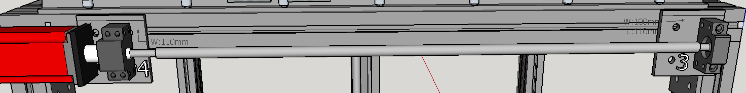

Bolts: DIN912 M6x30: 3x   
Hexagon nut: DIN934 M6: 4x  
Bolt: DIN7991 M6x30: 1x

# Step 4

Attach fixed bearing and floating bearing to plate 1

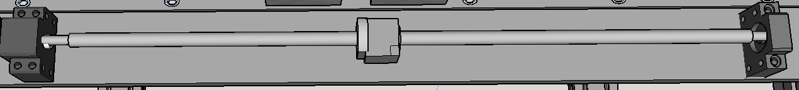

Bolts: DIN912 M6x30: 4x  
Hexagon nut: DIN934 M6: 4x

Step 5

Attach plate 3&4 to frame

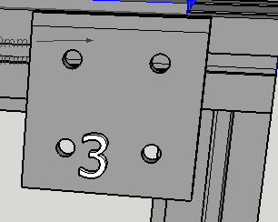

Sliding nuts: M8:10x  
Bolts: DIN912 M8x16: 8x  
Bolts: DIN7991 M8x16: 2x

Step 6

Install stepper motors to fixed bearings

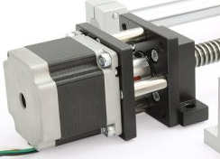

Bolts: DIN912 M5x18: 12x   
Hexagon nuts: DIN934 M5: 12x

Step 7

Attach supported rail to frame

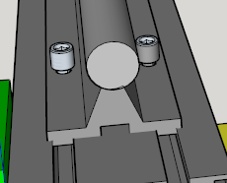

Sliding nuts: M5: 24x;  
Bolts: DIN912 M5x18: 24x

Step 8

Attach supported rail to aluminium plate 1

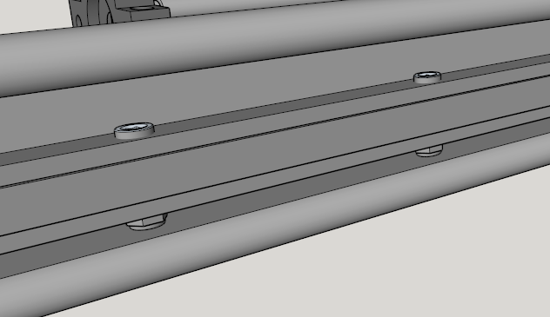

Bolts: DIN912 M5x30: 12x  
Hexagon nuts: DIN934 M5: 12x

Step 9

Attach linear motions to aluminium plate 1

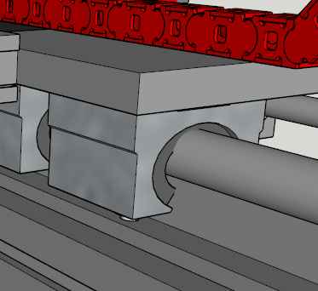

Bolts: DIN912 M6x20: 14x  
Bolts: DIN??? M6x20: 2x

Step 10

Assemble aluminium plates 1&2

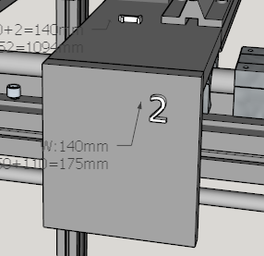

Bolts: DIN912 M5x30: 4x

Step 11

Assemble aluminium plates 5,6&7

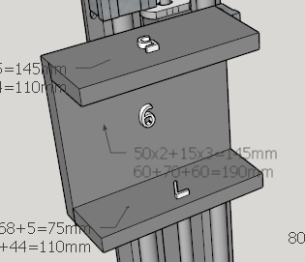

Bolts: DIN912 M5x30: 4x

Step 12

Attach linear motions to aluminium plate 6

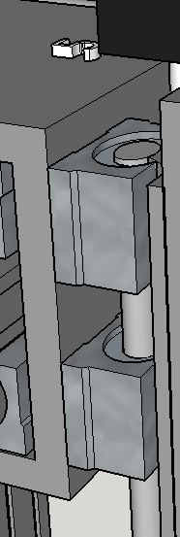

Bolts: DIN912 M6x20: 8x  
Bolts: DIN??? M6x20: 8x

Step 13

Attach linear motions to aluminium plate 5&7

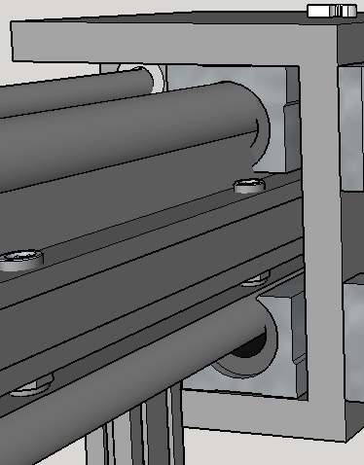

Bolts: DIN912 M6x20: 16x

Step 14

Attach ball-screws to aluminium plate 2,5 & 6

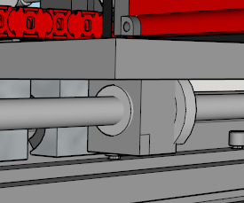

Bolts: DIN912 M5x25: 8x  
Bolts: DIN912 M5x20: 4x

# Step 15

Fix Z axis with plate 8&9

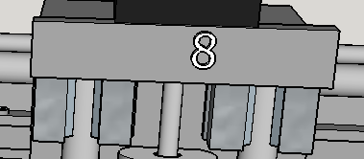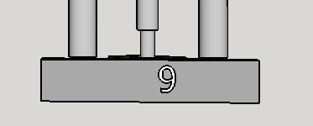

Bolts: DIN912 M6x25: 12x  
Hexagon nuts: DIN934 M6: 12x